 | The Goddard School of Collegeville, Pa. |  | September, 2019
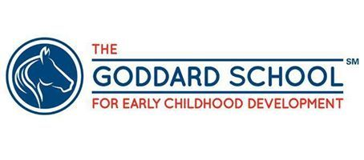

Are you Looking for a jump start to your career in early childhood?
Here at The Goddard School, we pride ourselves on mentoring and coaching young people as they begin their careers in early education! Whether you are looking to work in child care or in the school systems, The Goddard School of Collegeville is a wonderful starting point.  This Photo by Unknown Author is licensed under CC BY |  | Don’t want to work nights and weekends? Want to be done with work by 6 PM so you have time for homework? We offer year-round, seasonal and school year positions, Monday through Friday, that may complement your school schedule and give you experience in a PA Department of Education licensed facility. We offer student teaching and field experience opportunities, depending on the college you choose to attend, and offer CDA credential reimbursement through Penn State Better Kid Care, if you have just begun that process and will not complete it in High School. | How do you apply?  We are open from 7 AM through 6 PM, Monday through Friday. You may call the number below during those hours, email the contact below, or simply stop in for an application! You may also apply online through our website at: https://www.goddardschool.com/philadelphia/collegeville-springhouse-drive-pa/careers

